Kernel - Hardware Resource Management

(CPU, Memory, I/O) Optimization

Dr Parvinder Singh,

Associate Professor, Lovely Professional University

G. Jayendra Kumar M. Purushotham T. Venkata Jayanth

12213710 12212767 12205857

jayendrakumar@lpu.in m.purushotham@lpu.in venkata.jayanth@lpu.in

**ABSTRACT :**

Resource management with effeciency is important for uplifting system performance and minimizing waste of common resources in the hardware space like CPU, I/O, and memory. This research introduces a structured and systematic path for efficient utilization of the hardware resources, which is necessary considering the growing complexity of modern computing systems.The said methodology uses a multi-leveled optimization method by encompassing dynamic resource allocation, load balancing, and scheduling techniques. The CPU level task scheduling algorithm that uses machine learning models for resource prediction and allocation of CPU cycles to ensure that there is no resource contention while at the same time attaining the highest CPU utilization resulting in better throughput and reduced latency, respectively.To make I/Os fast, data storage uses a hybrid of SSDs and HDDs with intelligent placement strategy. The data is judiciously distributed across the storages which have these rate of access and the performance requirements in mind thus the chances of the I/O bottlenecks are minimized and the system becomes responsive.Memory management is realized through a cooperative caching mechanism, which self-adaptively applies different cache sizes and eviction policies to the current workload memory resource utilization properties as well as reducing costly page faults.Exhaustive testing of the method on multiple workloads confirms its superiority, which results in appreciable performance gains, efficient use of resources and better performance compared to existing methods. This study reshapes the belief in the usefulness of this aggressive resource optimization method as the pertinent solution to the increasing needs in modern computing systems.

**1.INTRODUCTION:**

Management of hardware resources within the kernel of an operating system is key for performance of these systems by allowing responsiveness , efficiency and scalability. The kernel is responsible for managing the hardware resources such as CPU, memory,

and I/O devices and executing user programs and system tasks, while switching between the two tasks without any disruption. CPU optimization requires systematic scheduling algorithms that intelligently distribute CPU idle time among competing processes. As a result, they minimize idle time and maximize throughput by considering process priorities, thread concurrency, and CPU core affinities. The memory optimization is implemented by the dynamic management of physical and virtual memory resources to accommodate the running processes without excessive fragmentation and overhead created by the demand paging, virtual memory mapping, and efficient memory allocation algorithms. I/O optimization implements data rushing processes between peripheral devices and the memory, accelerates the performance of device drivers, schedules I/O operations to minimize latency and maximize throughput, and uses kernel-level caching mechanisms and the direct memory access to speed up the I/O performance. Achieving a high level of optimization in these areas is only possible after hardware architecture analysis, algorithmic design with many intricacies, and balancing performance, responsiveness with resource utilization issues.

**2.KEYWORDS:**

Kernel, CPU, Hardware, Memory, I/O,Optimization.

**3.Optimization:**

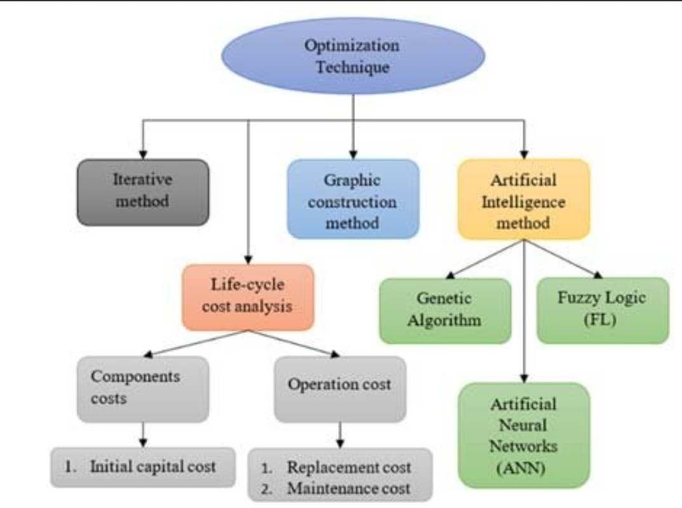

**3.1 Core Functionality:**

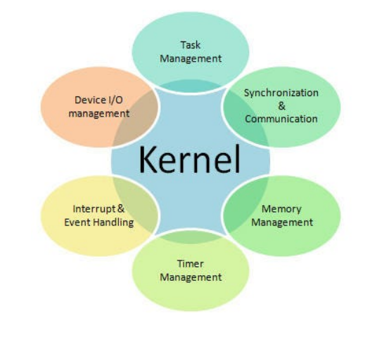

The kernel is the distinct and important part of an operating system, which performs a vital function of managing hardware resources including, of course, the CPU, memory, and I/O devices. It does this job by acting as the chief director that effectively assigns these resources and coordinating them in such direction as to achieve high system performance and operational efficiency. The kernel's main purposes are that it should schedule and use processor resources effectively, manage memory to accommodate the processes which are running in the best way possible by having the least system overhead, and carry out input/output operations fast and efficiently to minimize latency and maximize throughput. The kernel addresses resource contention, sensitivity, and performance/responsiveness trade-off by means of intensive algorithms and strategies in a way that is skillful and precise. How granular and sagacious its resource management hardware it is, the more such as an efficient one system computing.

**3.2 CPU Optimization:**

CPU optimization at the level of the kernel incorporates the use of sophisticated scheduling approaches that are principally aimed at deciding which processes can be both active and passive and subsequently assigned to the CPU. The equally important aims are maximizing CPU utilization, providing minimal latency and load balancing the workload among CPU cores. In order for the kernel to make these objectives real, usage of techniques, for example, process prioritization, which allow higher-priority processes to be given more CPU time. Preemption among processes is an imposition of interruption and rescheduling of tasks with lower priorities to grant prompt replies to the priority processes. Also, employed are multi-core and multi-threaded scheduling policies which distribute workload dynamically across available CPU cores enlisting the parallel computing capabilities to further enhance the system throughput and improve its efficiency. The kernel of the system handles the elaborated allocations of CPU resources, thus optimizing its performance, and guaranteeing that all its computing power is utilized optimally.

**3.3 Memory Optimization:**

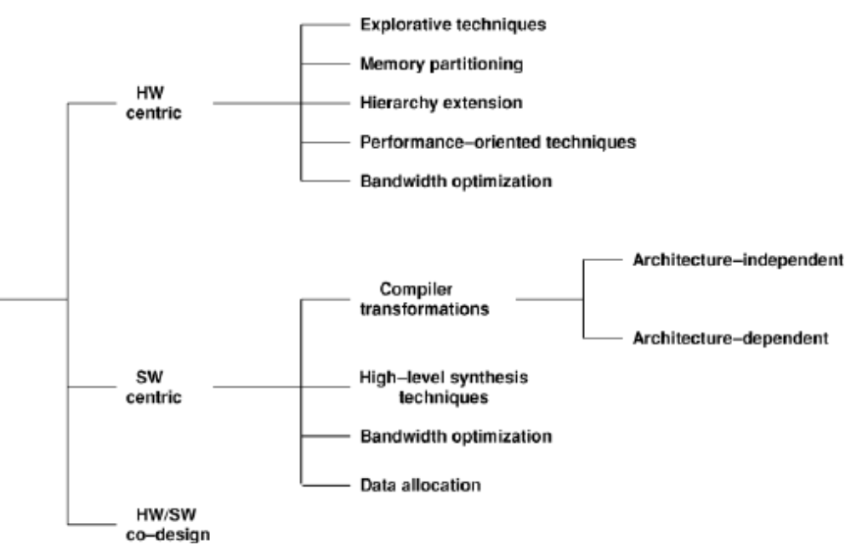

Memory optimization is like keeping your room organized It helps your computer to use the physical and virtual memory resources efficiently. Technique such as paging and memory mapping function as files system in a way that they make irrevalent data disappear and the needed data come to the forefront. One way of conducting this organized memory is via programming algorithms, for instance equal-size tasks assigned to shelves will not cause fragmentation. Just like you wouldn't want strangers having a free rein in your neat and tidy desk space, memory protection mechanisms work as security walls, keeping programs from each other's harm's way and keeping everything stable system-wise. This, in return, will make your computer run less cluttered and keep up with tasks more efficiently.

**3.4 I/O Optimization:**

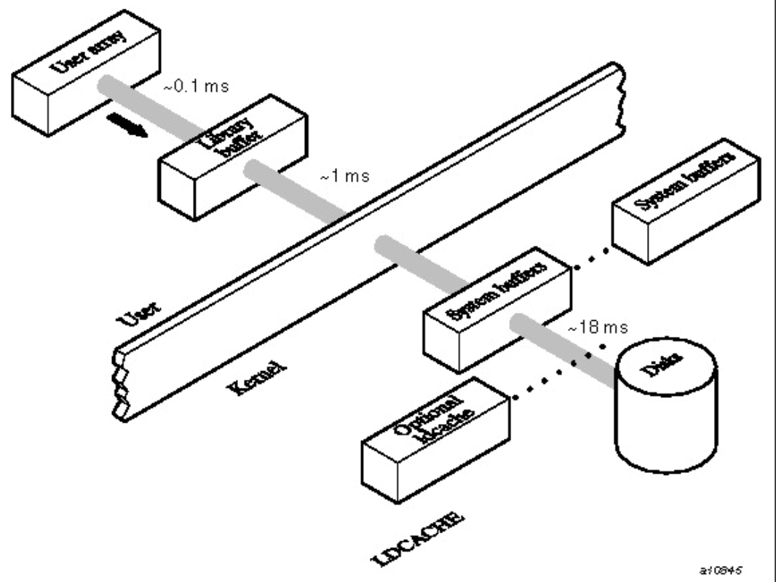

I/O optimization is like realizing that the redundant steps are slowing down you guys in the kitchen and removing them. Efficient drivers are the helpful waiters who make the order preparation and delivery process faster and flawless. I/O algorithms, such as the elevator algorithm, are constructed to provide the best order in the fulfillment of requests, consequently the waiting time is small. A technique called caching is like having a prep station with all the ingredients ready when you need to use them. Read-ahead caching forecasts wants and needs ahead of time, efficiently transporting goods to ensure faster delivery. Buffer caching keeps frequently used items to enable fast-tracking by placing them in the vicinity. Next, in Direct Memory Access (DMA) the delivery is done by somebody else. It eliminates the chip (processor) engagement in data transferring by transferring data directly between devices and memory , thus accelerating the speed of services. With an efficient I/O mechanism, the computer can process data faster and deliver immediate outputs.

**4 Trade-offs and Considerations:**

 Obtaining high optimization inferred to CPU, memory and I/O management within the middle layer is not properly done by not operating on the middle layer by a delicate balance between performance, responsiveness, and resource utilization. Often times it resolves the conflict between an algorithmic complexity, an overhead and exchangeability and compatibility problem with an already installed systems and applications. Furthermore, instantaneity requires decision making with the precision nature and timeliness equals impeccable decision execution of essential tasks increasing the complexity of the optimization process. Proffered power management protections that are geared to always inspect and enhance the energy output are added to the picture and thus they become the main parameters for optimization. However, it should not compromise the performance and responsiveness of the power systems. Maintaining balance among the competing factors calls for fine-tuning that considers the tradeoff between advantages and disadvantages of optimization. Hence, the ultimate measure of success is to leave the results of optimizing processes and bring the benefits to customer satisfaction which is the reason behind the existence of companies.

**5 Hardware Architecture :**

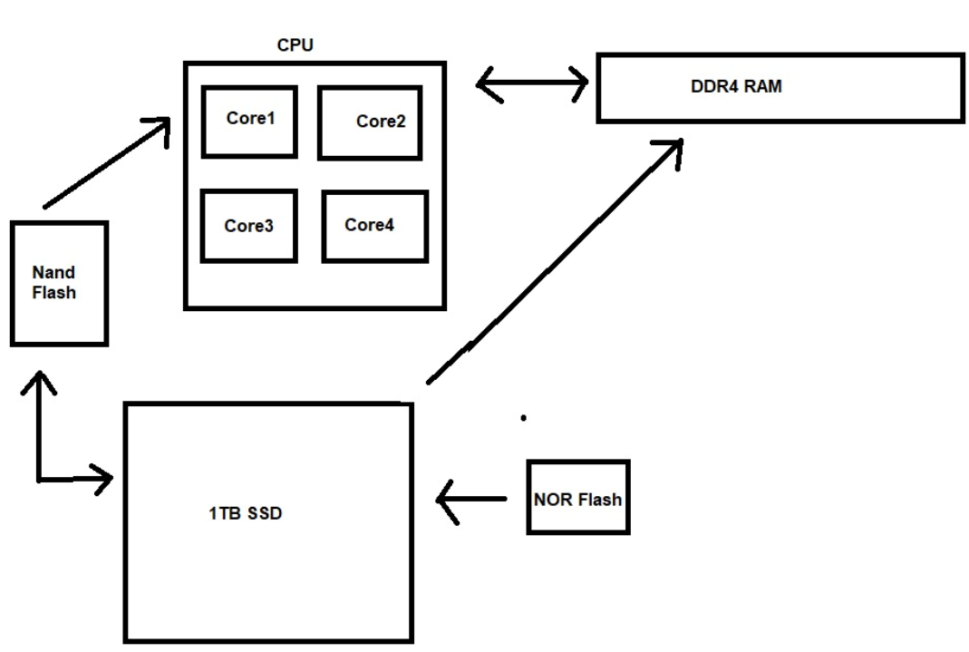

Hardware architecture awareness is like that blueprint without design.CPU 1.Microarchitecture: It is a purpose of this design - identifying the core parts of engine (number of cylinders), cache size (fuel tank size), and instruction pipelines (gearbox) - planning the each execution of processes. 2.Memory Hierarchy: Also, that is the fuel system. The memory storage is organized in the levels of storing (Registers, Cache, Main memory, Storage) that achieves different access speeds. Whether it is the data transfer between these tanks which we did for the engine or something else, all optimizations are equally important in this system.

3.I/O Device Characteristics: Without rims, these vehicles would be nothing but the frames that hold everything together. Awareness of the Hard disk's spindle speed (grip) and the network card's data transmission (tire pressure) rate is what makes the device to operate smoothly.

4.System Interconnects: It is these elements that resemble the way a car’s structure works. With this information, they are able to be preemptive towards not allowing data flow abnormalities such as bottlenecking which is the formation of where data congests.Thus when you have this skill you will be able to correctly and realistically apply memory strategy to the I/O that model of the tuner’s race car will be able to gain a lot faster comportment than a simple machine.

**6 Algorithmic Design:**

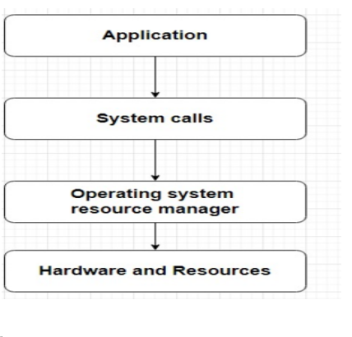

we can balance kernel-level resource management between the individual sound instruments because both of them play a vital role in the orchestra. While the I/O and the CPU perform different operations, the right balance of these two components will lead to better overall system speed. This is realised via the fact that the algorithms are clever.

1.Competing Demands: Imagine, let us say, the different instruments bowing to the conductor's arms. Algorithms determine what needs to be done immediately and what can be done later, depending on the significance of tasks and resource consumption. Before any further thing or any minor job gets noticed, it is the major issue that will settled first and towers over others.

2.Scalability: The ensemble should be more flexible if the numbers of the instruments stay the same. Scalable algorithms help overclocking problems with the help of distributing resources across multiple cores or data memory.

3.Responsiveness: Similarly, although algorithms react to smaller tempo changes, the conducting of the movie needs to be sensitive. It is vital that they timely reorganize resource fetching in response to the current demand as so to may keep the apply efficient regardless of the dynamic workloads.In order to profitably engage in these points, one need to have a deep understanding of the hardware architecture, that is, instruments’ ranges and capabilities. Due to a sense of prudence assembled from its knowledge and combined with highly advanced algorithms, the kernel can act like a conductor of an orchestra and therefore oversee all the hardware components performance

**Optimization Techniques**

**1. The Importance of Scrutinizing Kernel Updates for Performance and Stability :**

It is of great consequence in respect of the operational aspect. Change via updates gives rise to enhanced drivers with higher security and better speed, but occasionally can bring up bugs or errors. Check the versions changelog, documentation, and critics' reviews to make a sure that the update will not disturb your system stabilities and improve performance due to the version.

**2.Configure the kernel parameters**

Configuration for optimization: Tuning kernel parameters is possible so as to set parameters in such a way that the kernel behavior will be in compliance with the system specifications and the workload it is expected to process for the purpose of optimization. The system calls below the process level consists of kernels which decide on the allocation of memory, the procedure of scheduling algorithms, caching policies, networking, and controlling entry in log file. Parameter adaption is often helpful to achieve better performance, but to get the right effect the inner structure of the kernel either should be changed or improved,and the ramifications of those modifications on system performance should be thoroughly considered. For example, changing the memory allocation parameters may increase utilization, while by tuning scheduling parameters, the critical processes will be prioritized or processing will be CPU harmonic. Nevertheless, this can be a challenge which can make the place to fail and not be the best it can. Such actions as the creation of a null backup for the Z Download 100000 Free Unique Essays The application of kernel parameter configuration uses an optimization method which requires integrated knowledge of the workload behavior, hardware specifications, and kernel aspects so as to allow adapting the kernel’s behavior according to the employed computing environment’s unique requirements.

**3.Compile the kernel from source:**

Assembling the standard structure from the beginning gives technically literate users the freedom to either duplicate or create a customized version of their car engine. The soybeans are being not only expertly selected to participate in the areas where they can do their best and achieve the maximum yield. Try to picture this: of which transmission is different for electric cars that are focused only on tracks with high performance engine then it’s daily runners which need to be efficient as with their fuel spender.Feature Selection: A kernel, nevertheless, is responsible for some tasks which can be intermingled with its own in order to be divided in the right way during execution. An interpreter designed to unite all these sources with a certain file system and special devices is not the best choice. The use of specialized file system with a pre-defined architecture for maintaining the correct order is more appropriate. Design this piece with simplicity and less needless bells and whistles. The cards themselves are detailed without VRAM. In essence is this is supposed to cut down on business spending and get other appliances.Code Optimization: The issue is also like the example of the automotive engineer who tunes the inner components of the engine for improved performance and also the matter of fine tuning the code to work efficiently on a specific processor architecture. It could be with the help of adapting compiler settings to different options (like the ones that enable certain flag) that achieve small and yet the important performance improvements.I can assure you it is not an easy going, but it thus possible. This cruel dive makes a programmer not only physically proficient with the writing kernels but also has access to useful tools to clear the mist. As well, programmers have to be mentally and physically stable enough not to be weakened by these efforts. The process is like throwing the keys at a wysiwyg editor instead of a senior mechanic that works on your car. These factors may not provide support for you; clarification will be that pre-compiled kernels should be used, then they should be the choice.

**4.Update the kernel drivers:**

optimization: Linux kernel driver often include integrated code for peripherals. One would need to avoid old drivers and constantly performing updates are the other ways for optimum kernel performance. The user kernel modules act as an interface between the kernel and common hardware things like storage devices, network cards, and graphics cards. As time goes on, new drivers can provide better compatibility, extend functionality, and deliver higher performance by fixing bugs, enabling an upgrade to the software version, or increasing data transfer rates. Consequently, drivers' correctness, destabilization or crash may be resulted by new software release. Consequently, it is important to get information on what drivers are needed, documentation, and reviews from different users thoroughly so that you can make clean transition to the beastroxy update and as a result avoid issues that can degrade system functionality.

**5.Tune the kernel scheduler:**

Tweaking the kernel scheduler per se is a must-have optimization measure that can even leverage the total system productivity up to the usual pattern of the workload The kernel scheduler is the part that is always active so it can take the decision which processes gets access to the CPU core and that is a key factor in CPU utilization, responsiveness and throughput. Depending on the system requirement and performance targets, different timer functions can be used for example DLT scheduling for real-time applications, for fair sharing of resources EDF scheduling or for critical tasks RT scheduling. In addition there will be the fine-grained control on the scheduler that may be implemented by the tweaking the memory parameters for example, time slices, priorities of processes, or the CPU affinity, therefore, the scheduler will be much more precise.

Yet the kernel scheduler optimization requires the full knowledge of its operational principles as well as the compromise that is inherently present in the scheduling possibilities. System performance being monitored thoroughly including benchmarking, testing, and monitoring is crucial to ensure that any applied changes deliver what the system intended without ruining the stability or pass some other unintended consequences.Such 'kernel tuning' is achieved by closely monitoring the scheduling of the CPU, whereby the available hardware resources are used to the fullest extent. The decisions that the kernel scheduler makes therefore become unique to the specific demands of the given workload and application, leading to optimal performance on a broad spectrum of applications and use cases.

**6.Optimize the kernel memory management**

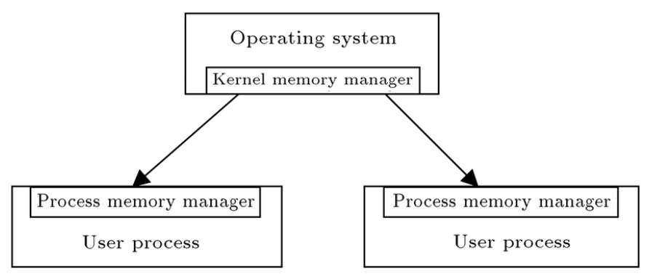

The best way to save memory is by mastering kernel kernel memory management, which will enable more memory efficiency, availability and speed. Among the responsibilities of the kernel is the making and destroying of memory allocations for kernel operations and processes owned by users. However, this is only one of the many important tasks performed by a kernel. The users might be in a position to toggle swaps, huge pages, or transparently huge pages and so on, depending on their memory usage and/or the size of the system memory. Furthermore, with configuring the swappiness, min_free_kbytes or the overcommit_ratio, gives the system room to alter the memory allocation and reclaim policy parameters. Nonetheless, this understanding must be deeper by picking storage architecture memory and determining the influence of each feature and parameter on performance. Accurate memory measurement, data on the changes, and the growing load of the node must be done before opting for any kernel memory management optimization to get the desirable results.

**7.Feedback-Controlled ResourceManagement :**

Feedback control theory has been exploited to develop adaptive control schemes and optimize system resource management at kernel level. Researchers suggest adaptive mechanisms that are feedback-driven, which dynamically allocate resources, fine-tune sensitivity parameters, and enable perfecting of overall system adaptation, based on feedback metrics and performance objectives. Besides the real-time systems, we present the power-aware computing, multi-core architecture, security, networking, heterogeneous computing and feedback control theory. These studies validate the universal application of feedback control methods which enable optimization of kernel-level resource management based on any computing environment and performance requirements. With using feedback loops researchers try to design adaptive and self-closing strategies of resource management which can be running under different workloads and constraints but still be able to keep optimal system performance.

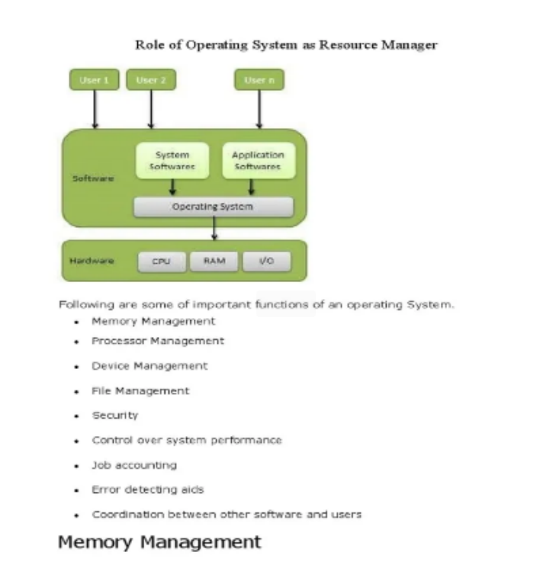

**Conclusion:**

Finally, an efficient and effective hardware resource management in the operating system kernel is one of the important component of obtaining high-performance and efficient computing systems. The kernel is a central brain that cleverly divides and allots the various resources such as CPU, memory or I/O devices. Through the usage of the leading techniques like advanced scheduling algorithms, memory management strategies, and I/O optimization, the kernel ensures that resources are being used to the maximum extent possible while I/O latency and responsiveness are minimized. Similarly, applying modern methods, especially the feedback control theory, will allow the system to demonstrate adaptive and self-regulating behaviors. Nevertheless, this procedure is quite a challenge, since it involves tremendous knowledge of hardware architecture, intricate algorithm design, and choice of the most effective performance metrics. Having these principles in kits as well as state-of-the-art optimization techniques, operating system developers create kernels that lead to the higher performance, scalability, and efficiency, meeting the ever-growing requirements of modern computing areas.

**References:**

1. Operating System Concepts

Authors: Abraham Silberschatz, Peter B. Galvin, Greg Gagne

Publisher: Wiley

2. LinkedIn:

https://www.linkedin.com/advice/0/what-best-ways-optimize-kernel-performance-skills-operating-systems